RNL-TBC-UK
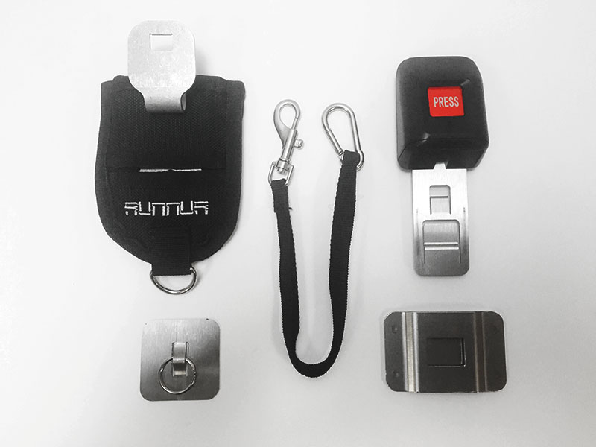
The Tablet Belt Clip is the first and only product of it’s kind. It will allow you to lock and carry any standard device on the side of your hip, and then access it within one second when needed. Simply bond the Mounting Plate and Tether Plate onto the back of the device case (**Case Not Included – Attaches to Your Case**), then, insert the Buckle attachment. When you are ready to wear it, simply attach the hip pad onto your belt, and clip the safety cord to the tether plate. Watch video for full demonstration.
Please note: Larger devices like the Surface or iPad Pro will likely need the Tablet Tool Belt as they are much heavier.
https://www.mobiletechgear.com/shop/tablet-belt-clip/
Benefits Include:
The Tablet Belt Clip allows you to easily carry a table on your belt like any other tool
Easy to assemble Mounting Plate secured with VHB™ peel and bond adhesive [Tensile Strength 90lbs sq/in]
Buckle Mechanism locks tablet to hip when not in use
Quick-Press release button allows instant access to tablet in less than 1 second
Security Cord [included] prevents dropping to avoid costly delays in repair
Reduces the probability of loss and theft
Perfect for jobs that require two hands by freeing up an “additional hand”
Ideal for: Builders – Adjusters – Inspectors – Roofers – Electricians – HVAC – Service Tech – Landscapers – Architects – Retailers – Field Workers – Farmers – Medical Professionals

